It’s true! We are already thinking about the end of summer when the kids we serve at Boise Rescue Mission Ministries are faced with the demand for school supplies, and school clothes.

**BACK TO SCHOOL SUPPLY DRIVE**

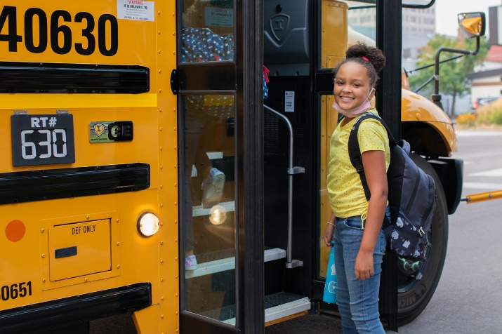Most of the children (80%) participating in the Rescue Mission’s Kids Program reside with their mothers at the Mission’s women and children’s shelters. The remaining 20% are former City Light residents or low-income children from the community who need the assistance and attention we are able to provide.

With your help, the Kids Program at City Light and Valley are working to break the cycle of homelessness in the lives of these kids. We provide for the basic needs of children and moms in need across the Treasure Valley: food, shelter, and clothing. But we also ensure that they have additional opportunities for success through education, counseling, and activities. Helping our kids be successful in school is a big part of what we do.

**SCHOOL SUPPLY NEEDS LIST**

* Composition notebooks (college ruled)
* Composition notebooks (wide ruled)
* Spiral Notebooks (wide ruled)
* Multi-Color Highlighters
* Dry erase markers / erasers
* Earbuds
* 1-3 inch binders clear view binders
* Book covers (XL)
* 2 Pocket folders
* Colored pencils
* Pens
* Sharpies (black)
* Facial tissue
* Zip lock bags (gallon & quart)
* Sanitizing wipes
* Graph Paper

**THINGS YOU CAN DO**

1. **Sponsor a child** with a new back to school clothes and more. **Call 208-3434-680 or email** [**school@boiserm.org**](mailto:school@boiserm.org) to receive a child/children’s information.

***Can’t be a full sponsor?***

1. **Donate** single items of clothing or shoes; and school supplies. Your donations can be dropped off at City Light Home for Women and Children in Boise, 1404 W. Jefferson, or at Valley Women & Children’s Shelter in Nampa, 869 W. Corporate Lane. Want to help, but don’t have time to come by with a donation? Give a gift online at [www.BoiseRM.org/give](http://www.BoiseRM.org/give), or by calling 208-343-2389.
2. Write an **Encouraging Note** to one of the children. We will put it in their backpack and send them to their first day of school knowing that you care about them. The form is on our website at BoiseRM.org/back-school-backpacks.

**Thank you for everything you do for the Mission and for the children we serve!**

Boise Rescue Mission Ministries • www.BoiseRM.org • **208-343-4680** •  email[**School@boiserm.org**](mailto:School@boiserm.org)