To Assist with School Supplies
As you are shopping for your own back to school supply needs, add a couple extra pocket folders and a box of pens to your basket and help a needy child. Please see our needs list below for specific ideas.

Supply Needs

- 2 Pocket folders
- Colored pencils
- Pens (black & blue)
- Markers (thick & thin)
- Multi-color highlighters
- Dry erase markers & erasers
- Sharpies (black)
- Mechanical pencils & lead
- Erasers
- Pencil sharpeners
- Pencil boxes
- 12” Rulers
- Glue & glue sticks
- Composition notebooks (college ruled)
- Composition notebooks (wide ruled)
- Spiral notebooks (wide ruled)
- Graph paper
- Index cards
- Sticky notes
- Protractor
- Calculators
- Ear buds
- Flashcards (addition & multiplication)
- 1-3 inch Binders (clear view)
- Book covers (XL)
- Facial tissue
- Zip lock bags (gallon & quart)
- Sanitizing wipes

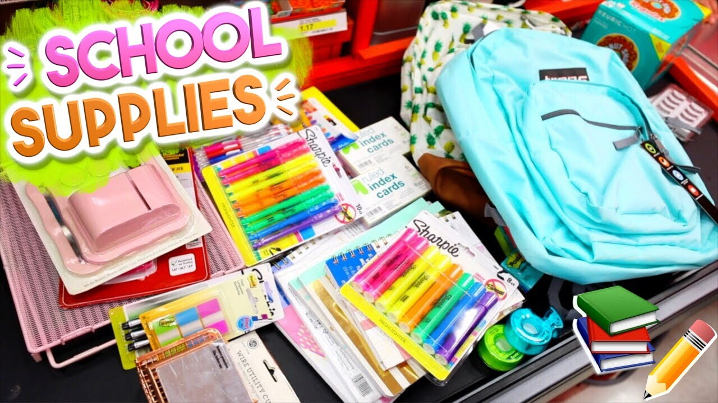
Supplies We Don’t Need
(We have an abundance of)
- Crayons
- #2 pencils
- Scissors
- Compasses
- Spiral college ruled notebooks
- Pencil top erasers

If you have any questions, please don’t hesitate to contact us at 208-343-4680.

Delivery:

Boise
Ministry Center & Warehouse
308 S 24th Street
Boise, ID 83702
208-343-2389
Nampa
Valley Women & Children’s Shelter
869 West Corporate Lane
Nampa, ID 83651
208-475-0725

Thank you for everything you do for the Mission and for the children we serve!

Boise Rescue Mission Ministries • www.BoiseRM.org • 208-343-4680 •  email School@boiserm.org

